**EX 5: IMPLEMENT PROGRAMS FOR ESTIMATING AND ELIMINATING TREND IN TIME SERIES DATA-AGGREGATION,SMOOTHING.**

**DATE:**

**AIM:**

To estimate and eliminate trends in time series data using aggregation and moving average smoothing techniques for better analysis and forecasting.

**ALGORITHM:**

1. Load the dataset and read the time series data into a Pandas DataFrame.
2. Convert the date column to datetime format and set it as the index.
3. Plot the original time series data to visualize trends and patterns.
4. Apply aggregation (resampling) by computing the quarterly mean to estimate long-term trends.
5. Plot the aggregated data to compare it with the original time series.
6. Apply moving average smoothing using a rolling window to eliminate short-term fluctuations.
7. P**l**ot the smoothed data to observe the trend-free time series for further analysis.

**PROGRAM:**

**import pandas as pd**

**import numpy as np**

**import matplotlib.pyplot as plt**

**# Load dataset**

**file_path = "/content/airline-passengers (1).csv"**

**df = pd.read_csv(file_path)**

**# Display first few rows to understand the structure**

**print(df.head())**

**# Ensure 'Date' column is in datetime format**

**df.columns = ['Date', 'Passengers'] # Rename columns if necessary**

**df['Date'] = pd.to_datetime(df['Date'])**

**df.set_index('Date', inplace=True)**

**# Plot original time series**

**plt.figure(figsize=(12,5))**

**plt.plot(df, label="Original Data")**

**plt.title("Original Time Series Data")**

**plt.xlabel("Time")**

**plt.ylabel("Passengers")**

**plt.legend()**

**plt.show()**

**# --- Aggregation: Resampling by Quarter ---**

**df_quarterly = df.resample('Q').mean()**

**# Plot resampled data**

**plt.figure(figsize=(12,5))**

**plt.plot(df_quarterly, label="Quarterly Aggregated Data", color='red')**

**plt.title("Trend Estimation Using Aggregation (Quarterly)")**

**plt.xlabel("Time")**

**plt.ylabel("Passengers")**

**plt.legend()**

**plt.show()**

**# --- Smoothing Using Moving Average ---**

**window_size = 5**

**df_smoothed = df['Passengers'].rolling(window=window_size, center=True).mean()**

**# Plot smoothed data**

**plt.figure(figsize=(12,5))**

**plt.plot(df, label="Original Data", alpha=0.5)**

**plt.plot(df_smoothed, label="Smoothed Data (Moving Average)", color='green')**

**plt.title("Trend Elimination Using Moving Average")**

**plt.xlabel("Time")**

**plt.ylabel("Passengers")**

**plt.legend()**

**plt.show()**

**OUTPUT:**

**Month Passengers**

**0 1949-01 112**

**1 1949-02 118**

**2 1949-03 132**

**3 1949-04 129**

**4 1949-05 121**

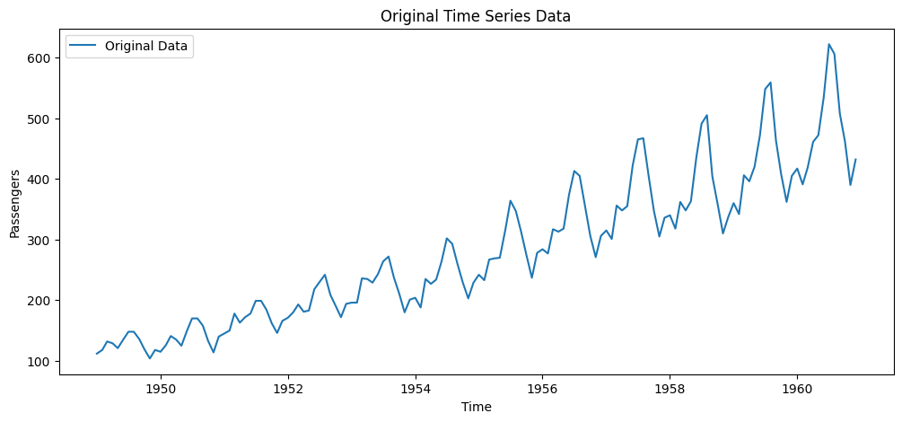

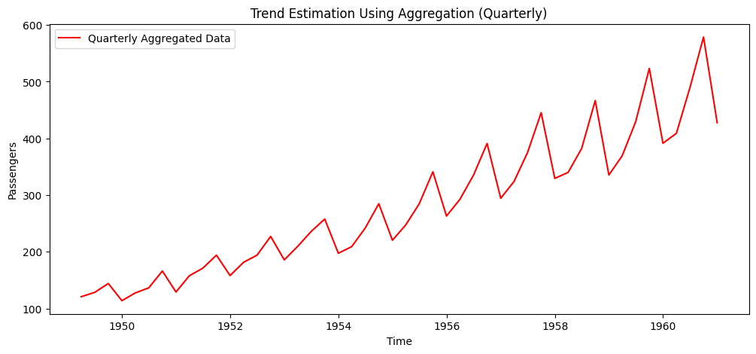

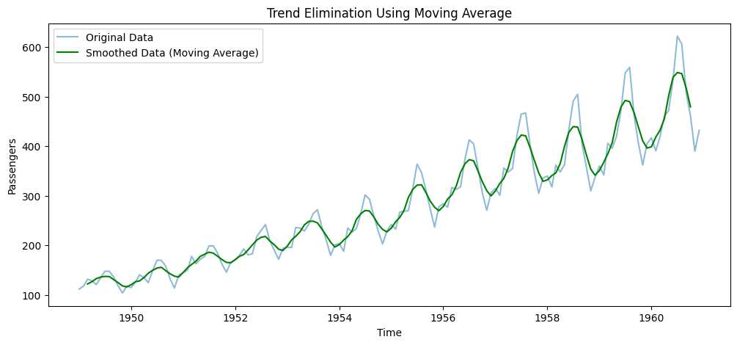

**RESULT:**

The program successfully identifies trends in time series data using aggregation and removes short-term fluctuations using moving average smoothing, making the data more suitable for analysis and forecasting.